Putting your UX designs on paper as your write your specifications, help you to focus your thoughts and describe for the user, what they will see.

**Main Menu:**

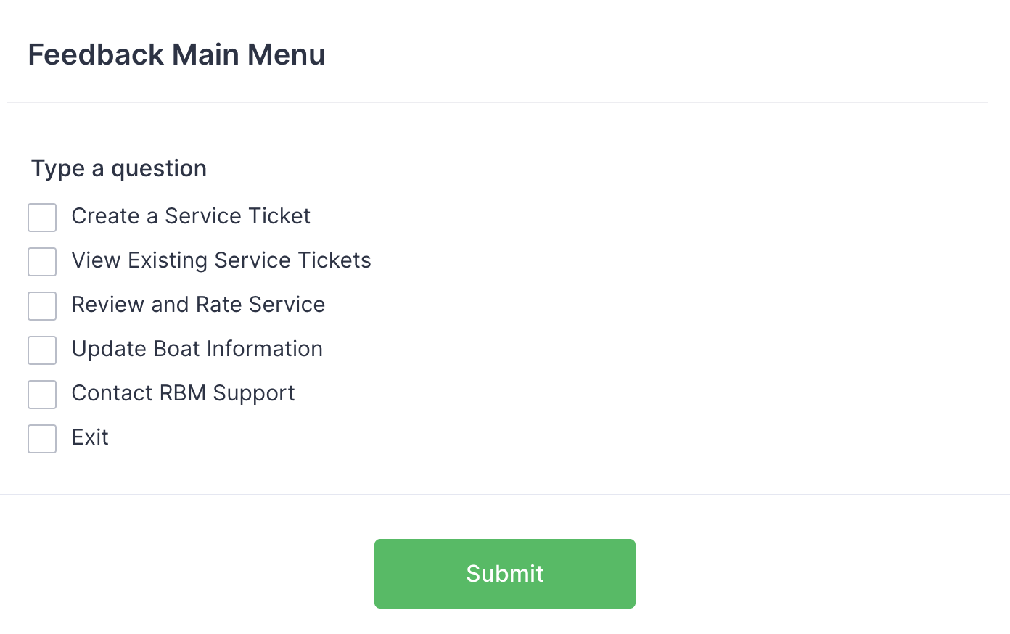

**Chooses Option 1: Create a Service Ticket**

**Displays the list of boats registered in the system.**

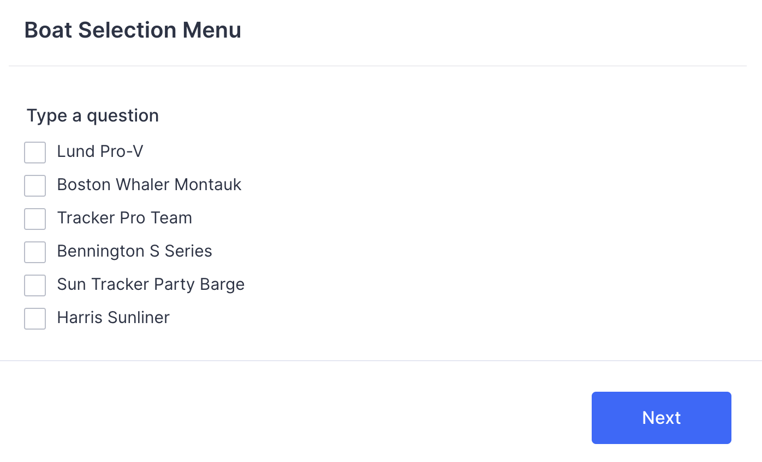

**Option 2: Selects the Boat #2**

**Problem Selection:**

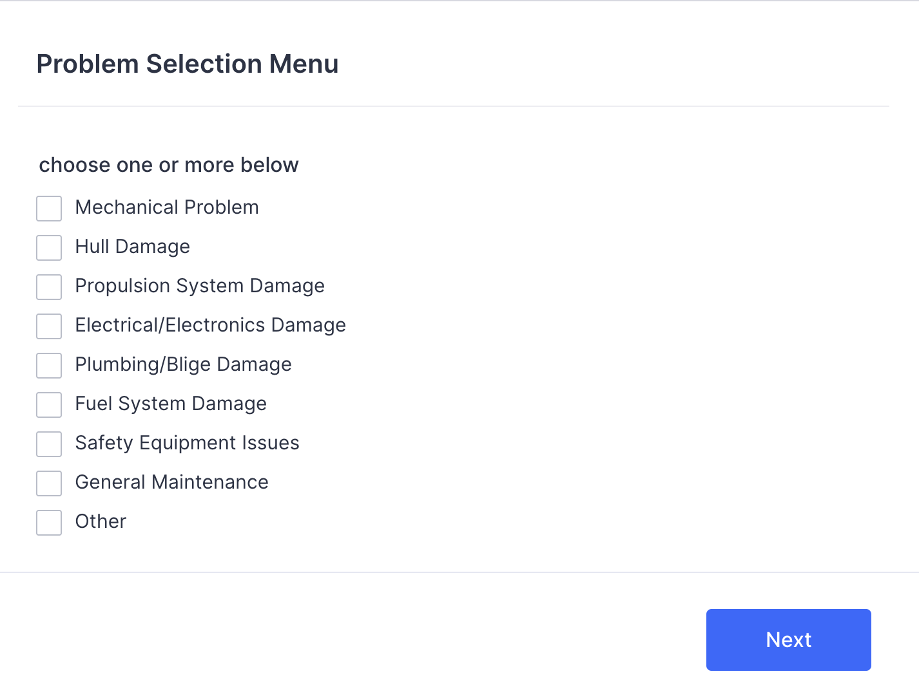

**Priority Level Selection:**

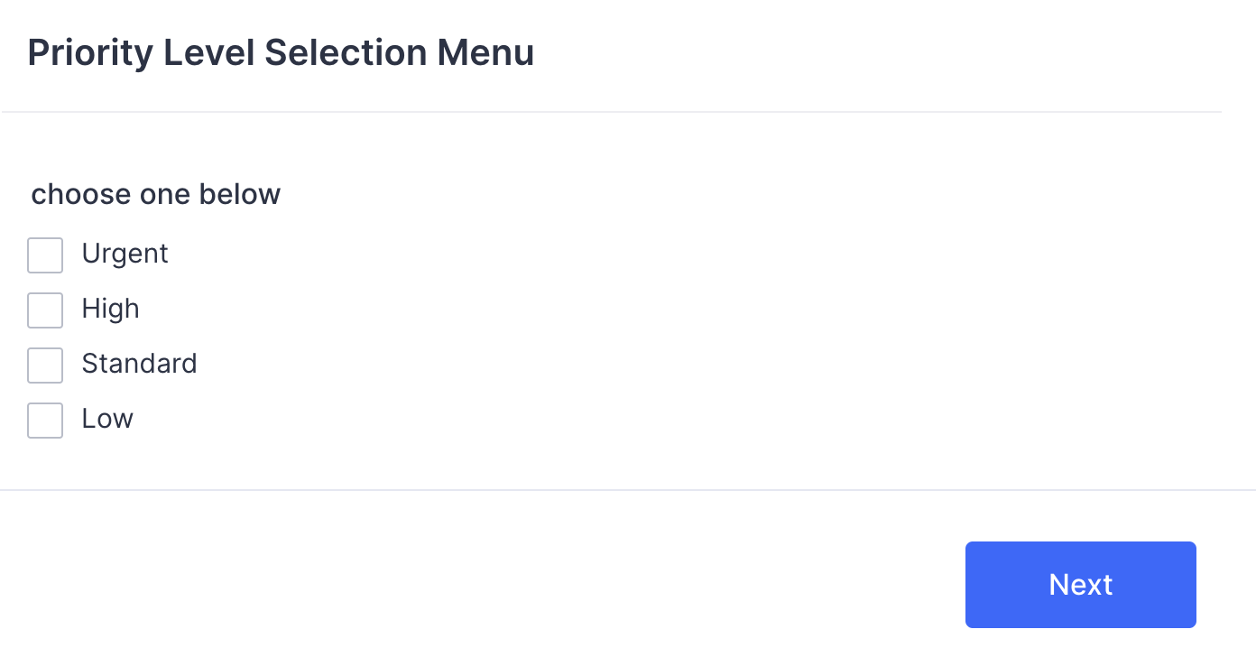

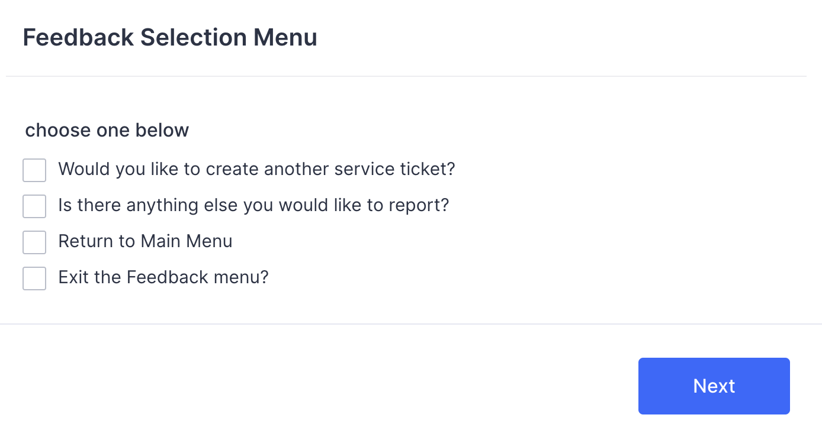

**User story –**

In the context of Round, the Bend Marina (RBM), the responsibility for overseeing the repairs of boats primarily falls under the purview of the RBM staff, specifically those involved in the marine workshop and boat repair services. In the provided information, Christy, Joe, and their son Jeremy are mentioned as individuals involved in running the marine workshop. Jeremy has assumed responsibility for the office side of the workshop.

Therefore, Jeremy, along with his parents Christy and Joe, would be primarily responsible for overseeing the repairs of boats at RBM. They manage and schedule work orders received from clients, order necessary parts and supplies, and bill clients when the work on boats is completed.

It's important to note that boat repairs may involve a collaborative effort among the RBM staff, including mechanics, technicians, and service personnel, to ensure that boat repair requests are addressed efficiently and effectively.**Activity Diagram – See Visual Paradigm model.**

|  |  |  |  |
| --- | --- | --- | --- |
| Use Case Name | Create Boat Repair Service Ticket | | |
| Triggering Event | Customer reports a boat repair request to RBM Service Staff about a Boat. Issue is usually received via phone call or email. | | |
| Brief Description | This use case enables the RBM service Staff to create a service ticket for any issues related to Boat repair or servicing. | | |
| Actors | RBM Repair Service Staff | | |
| Related Use Cases | N/A | | |
| Preconditions | 1. RBM staff have access to the RBM computerized system. 2. Customer's boat information is available in the system. | | |
| Post Conditions | A service ticket for boat repair is created in the system. | | |
| Flow of activities | Actor | | System |
|  |  | Request list of boats. | Retrieve and display a list of all boats that are registered in the system. Prompts for selection. |
|  |  | Choose a boat and enter customer's boat information - Boat owner's name, Boat registration number. | System captures and validates the entered data - Ensure boat registration number is valid and matches an existing customer record.  Prompts for selection and problem entry. |
|  |  | Enter the problem and its priority. | Create a new service ticket and assign a ticket number and today’s date to the ticket.  Ensure the repair request description is provided.  Retrieve and display a list of all Boat Repair Service Staff. |
|  |  | Submits the service ticket. | System validates the data and creates a unique service ticket ID.  System displays a confirmation message with the service ticket ID to the RBM staff.  RBM staff receives the confirmation message. |
|  |  | The service ticket is added to the RBM system's queue for boat repairs. | System updates the service ticket queue. |
|  |  | Repeat above step until all issues are ticketed. | Prompts to save. |
|  |  | Save | Assign the service ticket to the unit and save the service ticket and the unit. |
| Exception Conditions | * If boat owner's name is not found in the system, the RBM staff may need to update customer records or request additional information from the customer. * If the repair request is not clear or complete, the RBM staff should contact the customer for clarification. * If the RBM computerized system experiences technical issues, the staff should follow established procedures for reporting and addressing system problems. | | |

S